**Section:- K19SD G:2 Project No.:- 44**



**Project Report:- Online Pizza Delivery**

Internet Programming Laboratory (CSE 326)



|  |  |  |  |  |  |
| --- | --- | --- | --- | --- | --- |
|  |  |  | **By** |  |  |
| **Sr. No.** | **Registration No.** | **Name of Students** | **Roll No.** | **Phone Number** | **E-mail** |
| 1 | 11914839 | Ojaswini Sharma | 43 | 7018596845 | sharmaojaswini7@gmail.com |
| 2 | 11914214 | Manikanta Rayala | 33 | 9550216236 | manikanta.rayala9@gmail.com |
| 3 | 11913880 | Vadla Naveen Kumar | 8 | 7993460468 | naveenvadla658@gmail.com |

**Submitted to Dipen Saini**

Lovely Professional University Jalandhar, Punjab, India.



# CONTENTS

1. **INTRODUCTION**
2. **NEED OF PROJECT**
3. **PROCEDURE FOR RUNNING THE WEBPAGE**
4. **LANGUAGE DESCRIPTION**
5. **STRUCTURE CHART**
6. **METHODOLOGY**
7. **RESPONSIBILITY**
8. **CONCLUSION**



# INTRODUCTION

A **WEBSITE** is a collection of web pages and related content that is identified by a common domain name and published on at least one web server.

The pages of websites can usually be accessed from a common root [URL](http://en.wikipedia.org/wiki/URL) that is **“localhost/WEBSITE/index.html”** and usually reside on the same physical server. The URLs of the pages organize them into a hierarchy, although the **hyperlinks** between them control how the reader perceives the overall structure and how the [**traffic**](http://en.wikipedia.org/wiki/Web_traffic) flows between the different parts of the sites.

**The working of the project is as follows:-**

The first page provides several links. The Home page contains several information about the site like about about us, contact us, sign in, order here etc.

The cash will be collected on delivery there is a login section for all the user. The user need to enter his details correctly or else the order shall stand cancelled.



# NEED OF PROJECT

* Pizza Delivery website helps the users to order any pizza product online from their home without facing any major issues.
* It also helps pizza shops to automate pizza selling online, and also helps pizza shops to take online orders.
* This system can be used to sell like chain of Pizza shops from a single site, as many pizza shops can join our site and they can serve their products to various parts of the country through our site if they are willing to join us.
* User can register on the system and get his online account on site. User can login to system and check various pizza items.
* The pizza products are viewed order here section. Users can click on the book and order any pizza he wants.
* This site provides home to home delivery and it requires less time for ordering and user also gets a lot of option for choosing the product.

**Procedure for running the webpage**



The site runs on java script, html and css. It also uses font awesome, animate.css, google fonts for making the site better in animation and

fonts. It also makes use of glyph icons so that the site looks more interactive and better.

The site has been edited using css and the alerts and all such functions of the site are created using java script.

The site contains the home page which consists of about us, contact us, login or sign in and order here. This how the site runs and the site rums as in first the user need to login and then there comes the contact us page where you can contact us on Instagram, Facebook, Pinterest, LinkedIn.

The site consists of a order here page where a page appears with a menu list and there are various pizzas listed in the menu list and in the menu list as soon as you click your desired order a form appears which asks details like user’s address, name and phone no. so that the order can be delivered in the correct location.

# LANGUAGE DESCRIPTION



## HTML

**Hypertext Markup Language** (**HTML**) is the main markup language for web pages. HTML elements are the basic building-blocks of Webpages.

HTML is written in the form of HTML elements consisting of *tags* enclosed in angle brackets (like <html>), within the web page content. HTML tags most commonly come in pairs like <h1>and </h1>, although some tags, known as *empty elements*, are unpaired, for example <img>. The first tag in a pair is the *start tag*, the second tag is the *end tag* (they are also called *opening tags* and *closing tags*). In between these tags web designers can add text, tags, comments and other types of text-based content.

Web browsers can also refer to Cascading Style Sheets (CSS) to define the appearance and layout of text and other material. The W3C, maintainer of both the HTML and the CSS standards, encourages the use of CSS over explicitly presentational HTML markup.

## CSS

**Cascading Style Sheets** (**CSS**) is a style sheet language used to describe the presentation semantics (the look and formatting) of a document written in a markup language. It’s most common application is to style

web pages written in HTML and XHTML, but the language can also be applied to any kind of XML document, including plain XML, SVG and XUL.



CSS specifies a priority scheme to determine which style rules apply if more than one rule matches against a particular element. In this so-called *cascade*, priorities or *weights* are calculated and assigned to rules, so that the results are predictable.

## JAVASCRIPT

**JavaScript** uses syntax influenced by that of C. JavaScript copies many names and naming conventions from Java, but the two languages are otherwise unrelated and have very different semantics. The key design principles within JavaScript are taken from the self and Scheme programming languages.

Contrary to popular misconception, JavaScript is not **“Interpreted**

**Java”**. In a nutshell, JavaScript is a dynamic scripting language supporting **prototype based** object construction. The basic syntax is intentionally similar to both Java and C++ to reduce the number of new concepts required to learn the language. Language constructs, such as **“if”** statement, **“for”** and **“while”** loops, and **“switch”** and **“try …. catch”** blocks function the same as in these languages.



# STRUCTURE OF WEBSITE

* **Sign In:-** Here the user can sign in providing a user id and password .
* **About Us:-** Here the user can view the pizzeria’s past history and how we started this idea and made this site.
* **Contact Us:-** Here the user can contact us via Instagram Facebook LinkedIn and Pinterest by clicking on the respective icons.
* **Order Here:-** Here the user can order the pizza by clicking on the order here section a page with a menu book appears where you can order any pizza you like as soon as you hit the pizza a page appears where you need to enter your details like your name, address and phone no so that the pizza can be easily delivered to your desired location.

# METHODOLOGY

The original intent of the mapping methodology was to determine a process for showing basically front-end of **“ONLINE PIZZA DELIVERY”.**

As we know a front-end of any website is a group of web-pages. Similarly, this website consist of the following pages:-

1. **Home:-** Home page is the first page or we can say welcome page consisting some information about the website that about what things does this site consists of and here in this home page we have provided some information about the website.
2. 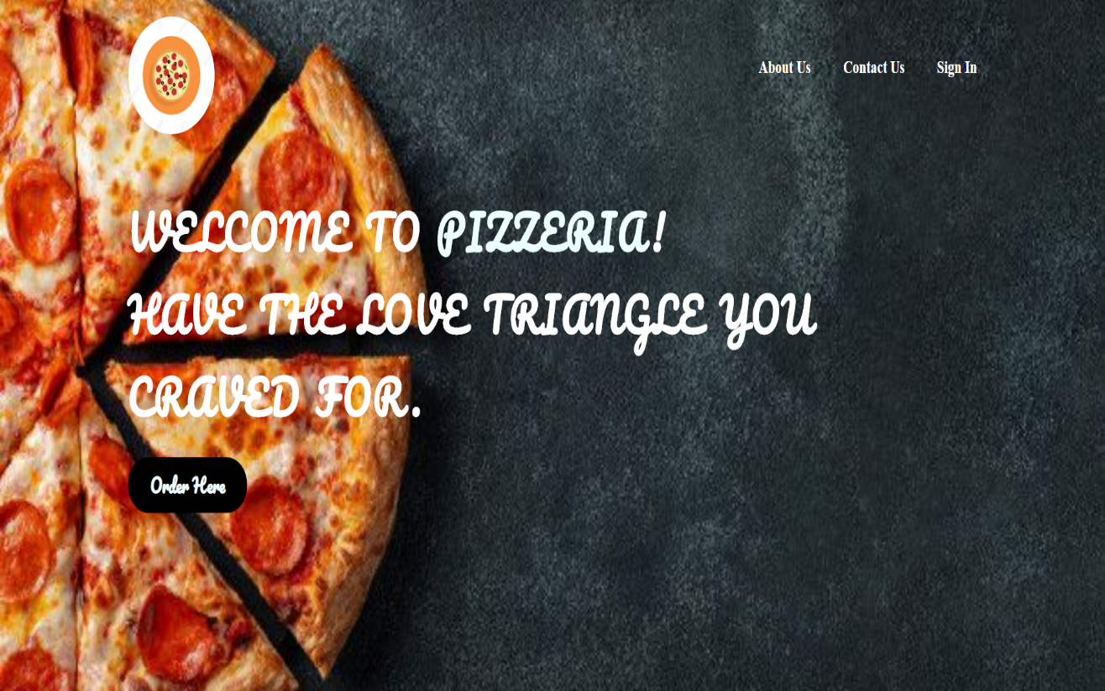

**Sign In:-** Here the user can sign in providing a user id and password.



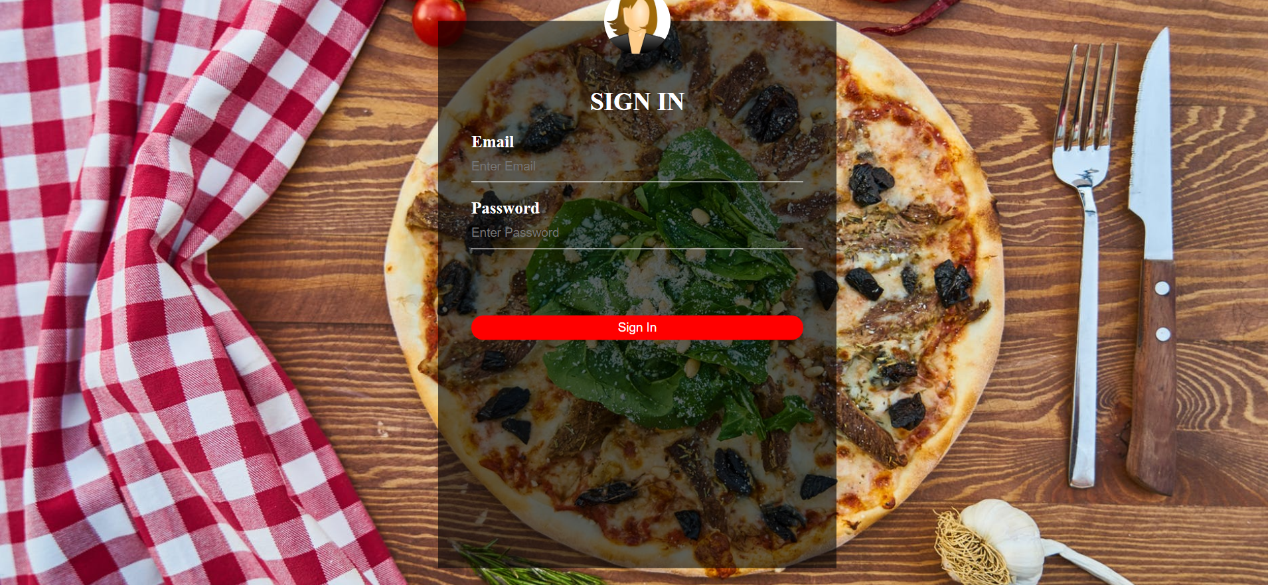

**About Us:-** Here the user can view the pizzeria’s past history and how we started this idea and made this site.

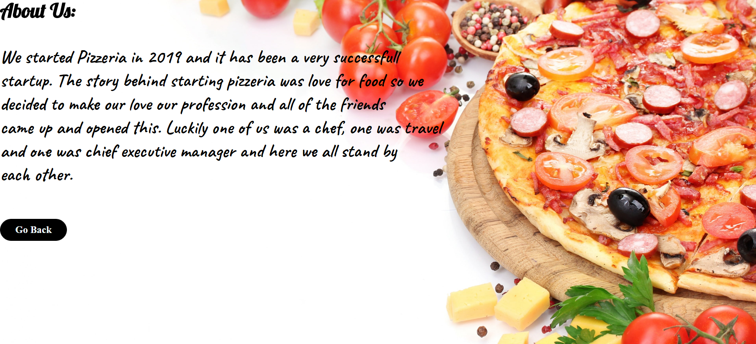

**Contact Us:-** Here the user can contact us via Instagram Facebook LinkedIn and n Pinterest by clicking on the respective icon.

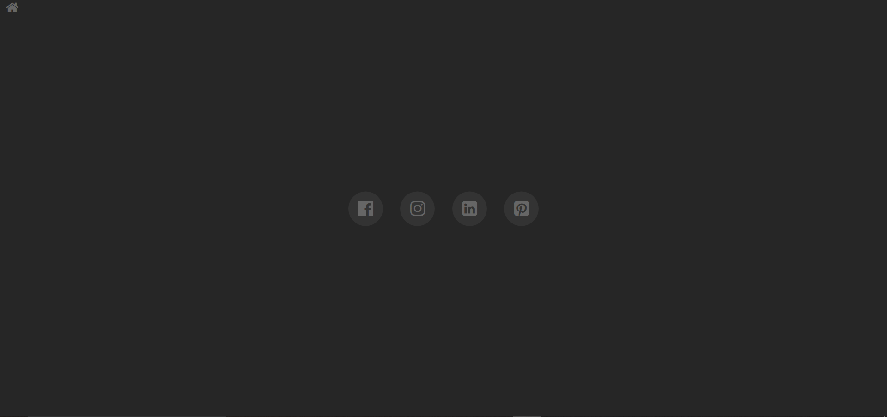

**Order Here:-** Here the user can order the pizza by clicking on the order here section a page with a menu book appears where you can order any pizza you like as soon as you hit the pizza a page appears where you need to enter your details like your name, address and phone no so that the pizza can be easily delivered to your desired location



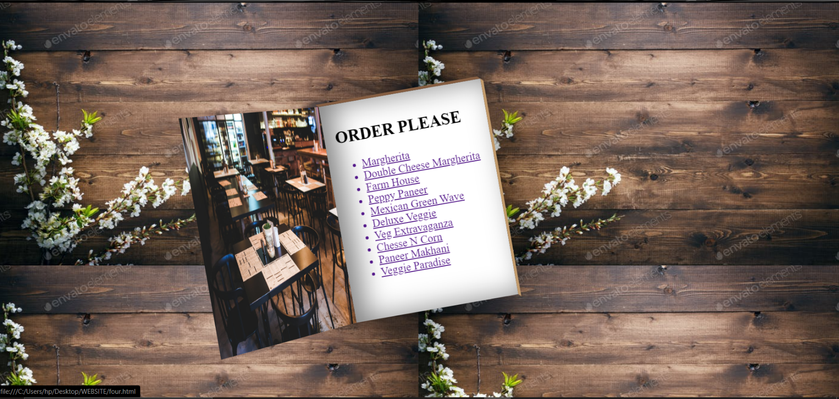

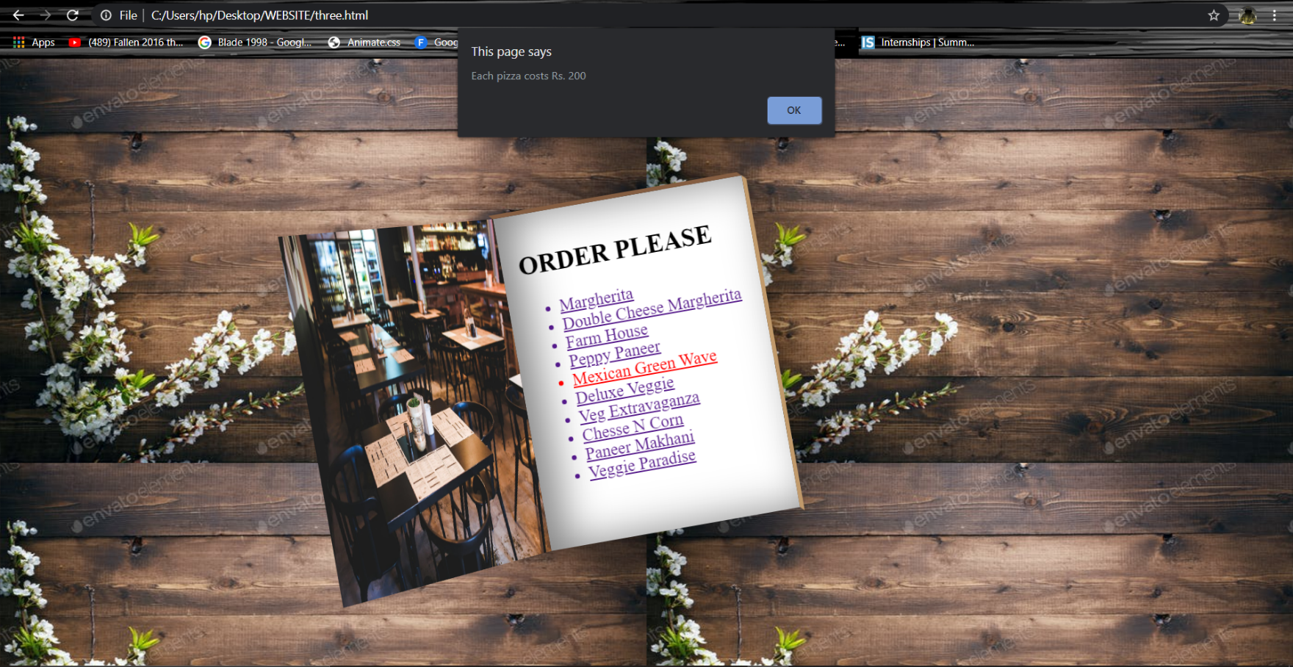

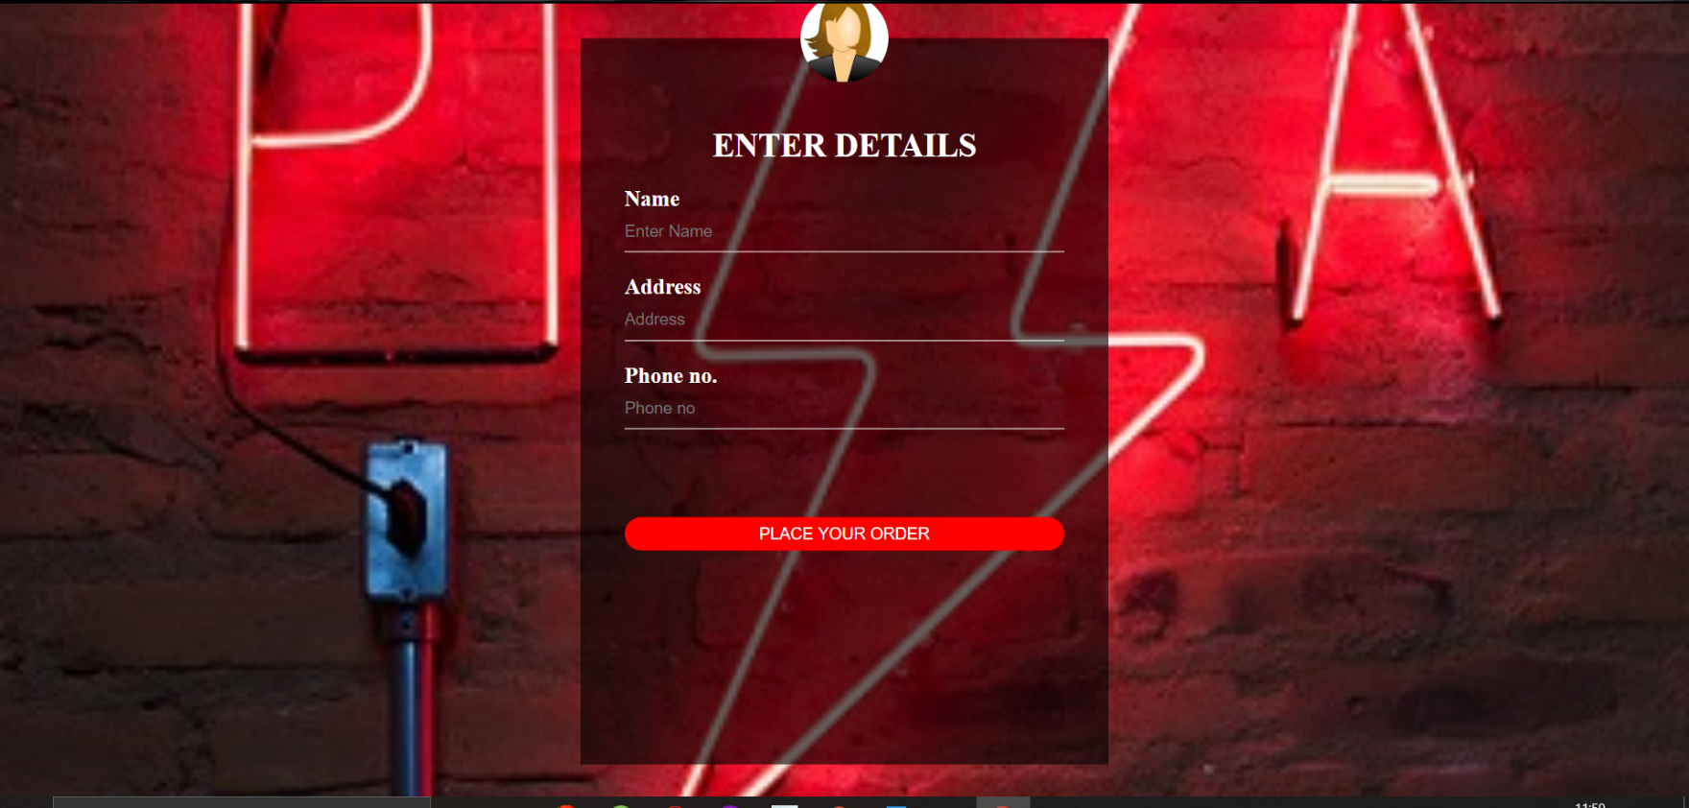

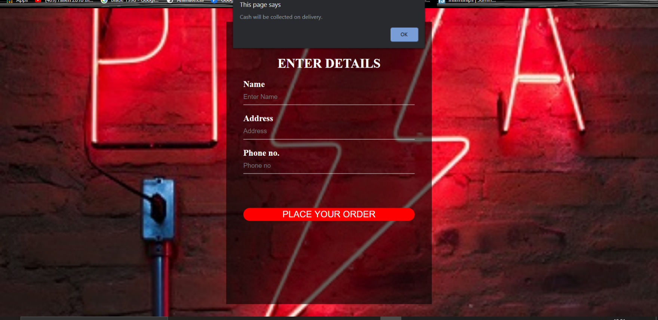



# RESPONSIBILITY

For this project the three of our team mates worked very hard Ojaswini Sharma in finding

Glpyhicons, animations, font awesome graphics and she worked on the whole css part.

Manikanta worked on the complete html and managed to find the perfect images for the

Project

Naveen worked on the forms and all the java script part and so this is how the responsibility

Was carried by each team mate very well.



# CONCLUSION

The project report entitled **“ONLINE PIZZA DELIVERY”** has come to its final stage. The system has been developed with much care that it is free of errors and at the same time it is efficient and has been designed using many languages like **“JavaScript”, “HTML”** and **“CSS”**. The important thing is that the system is robust. We have tried our level best to make the site as dynamic as possible. Also we have tried to maintain the pattern of the webpages and the size of the font as well. This program is totally the time consuming program we have done a lot of hard work in it, we have tried our best to represent this webpage in the attractive manner and all the functions are arranged in well manner.